The University of Tulsa


Design Project

Transient Multiphase Production Design

Authors: Acosta, Rodrigo
Dang, Ninh
Ravichandran, Sriram
Singh, Kriti
Professor: Dr. Zhang

Contents

Executive Summary 1

Design Procedure 2

Fluid Characterization 3

Well Distribution 10

Production Pipeline and Riser Selection 19

Drilling Schedule 24

Wellhead Chokes 36

Erosion Velocity Erosion 38

Shutdown and Start-Up in Pipelines 39

Transportation Line: 41

Flow Assurance 47

Three Phase Separator 55

Appendix: Design Project Statement 60

Executive Summary

- Tubing Selection
Tubing with 3.958-in ID and 0.271 wall thickness is chosen for all the wells in both Reservoir A and Reservoir B.

- Pipeline and Riser Selection
Pipeline with 20.0-in-OD and 0.82-in thickness and riser with 24-in OD and 0.87-in thickness is selected for reservoir A and B.
- Drilling Schedule
Table 1 – Production of Wells
- Transportation Line Selection
Reservoir 1
Gas transportation line: _24_-in O.D. and _0.87_-in wall thickness
Oil transportation line: _24_-in O.D. and _0.87_-in wall thickness
Reservoir 2
Gas transportation line: _20_-in O.D. and _0.82_-in wall thickness
Oil transportation line: _24_-in O.D. and _0.87_-in wall thickness

- Compressor and Pump Application on Platform
Reservoir 1
For gas transportation, compressor with a capacity of _0_ psi is needed
For oil transportation, pump with a capacity of__0_ psi
Boosting is not required.

Reservoir 2
For gas transportation, compressor with a capacity of ___ psi is needed
For oil transportation, pump with a capacity of___ psi
Not required

Design Procedure

A sketch of the first year production system is illustrated in Figure 1, with 16 wells in reservoir 1 and 15 wells in reservoir 2. The oil and gas fluid is produced and transported to platform and separated by the three phase separator for each reservoir. Compressor and pump are needed to transport gas and oil to shore. The gas and oil pressure on shore is 800 psia and 500 psia, respectively. Water is drained directly into the sea after the treatment.

Figure 1 - Overall production

Production design for reservoir 1 and 2, as well as the gas and oil transportation line is separated. Separator pressure is set to 100 bar in reservoir 1 and 10 bar in reservoir 1 in order to get more production. The fluid file is different in each case and it is introduced in the next section. In this design, diameters of tubing, production pipeline and riser, and transportation gas and oil line are selected based on the pressure drop, erosion velocity, production rate. Drilling schedule for the two reservoirs is proposed based on the designed oil and gas production rate. Water production is also considered in the design. From 3rd year, 4% water appears and it increased 4% every year thereafter. Transportation will be performed for each reservoir separately. Compressor and pump are needed to transport gas and oil to the shore, since the pressure at the separator is not enough for the transportation. Insulation of the pipeline is selected in the flow assurance part, with the consideration of wax deposition and hydrate formation. Pigging is needed in the gas transportation line.

Fluid Characterization
A fluid sample was obtained from both reservoirs and a PVT was performed on them. The results shown that both reservoirs have black oil characteristics, with high concentration of heavy ends. In the following tables, are summarized the composition used for the project design.

Table 2 – Composition Reservoir 1

Table 3 – Reservoir 1 Flash
Figure 2 – Reservoir 1 Envelope
It can be seen that the oil is characterized as black oil, with a critical point closed to the cricondentherm point. This represent a heavy oil with low content of dissolved gas. The bubble point at reservoir temperature (250 F) is 2396 psia.
Table 4 – Reservoir 1 Separator Test
Table 5 – Composition Reservoir 2
Table 6 – Reservoir 2 Flash
Table 7 – Reservoir 2 Separator Test

Figure 3 – Reservoir 2 Envelope
In this case, it can be pointed out that the oil is characterized as black oil, with a critical point closed to the cricondentherm point. This represent a heavy oil with low content of dissolved gas. The bubble point at reservoir temperature (250 F) is 3164 psia.
When analyzing the hydrate condition, the equilibrium curve P-T is needed. The following plot, describes this envelope for each reservoir.
Figure 4 – Hydrate Curve Reservoir 1
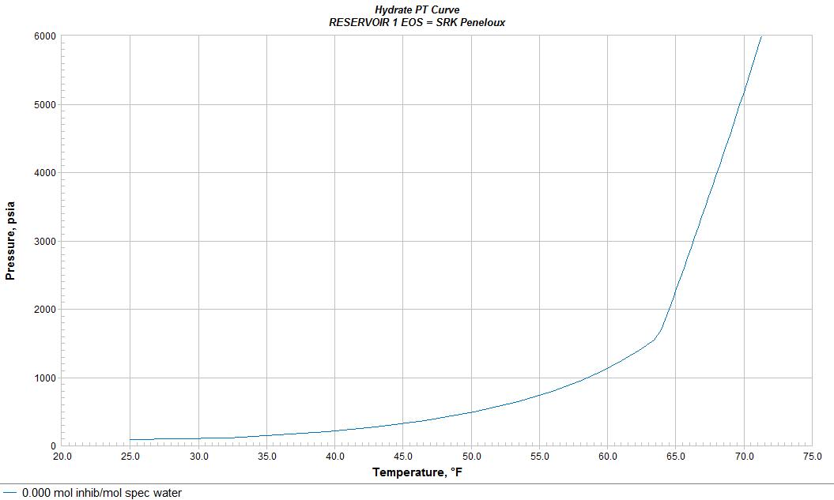
It does not contains dissolved salts.
Figure 5 – Hydrate Curve Reservoir 2
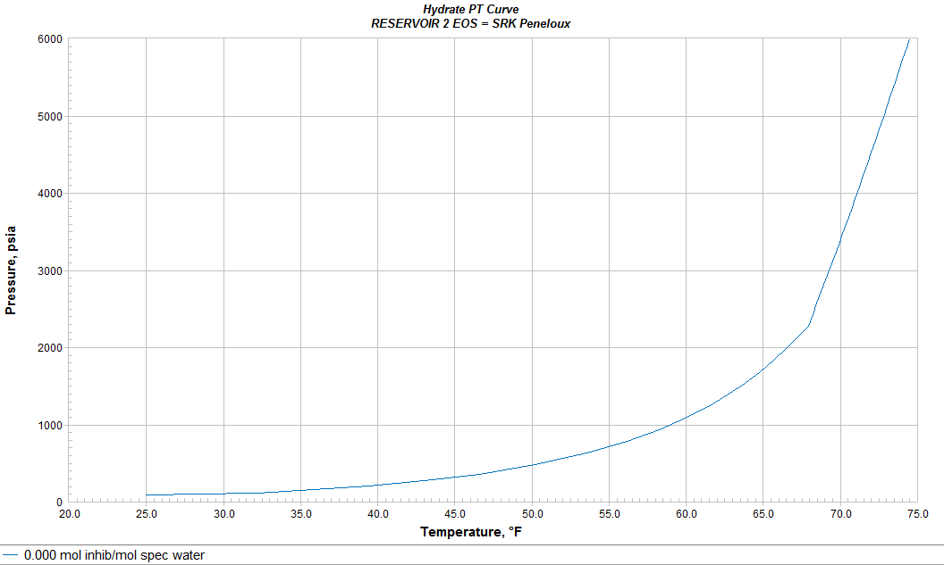

Well Distribution
There are three categories for drilled wells that is described in the following table.
Table 8 – Well categories
In order to fulfill this requirement, the wells to be drilled where distributed according to this particular criterion:

Figure 6 – Well Distribution Reservoir 1
The wells will be distributed in three different rows, 200 ft, 600 ft and 800 ft from the manifold. For reservoir 1 the sequence is: 4 wells in 200 ft, 4 wells in 600 ft and 4 wells in 800 ft. Any additional well will be incorporated with the present priority: 200 ft, 600 ft and 800 ft. Then repeat as many times as needed. In this way, all well categories is met.

Figure 7 – Well Distribution Reservoir 2
In the case of reservoir 2, the idea is basically the same. The field is divided into four concentric lines, 200 ft, 400 ft, 600 ft and 800 ft., which separates all drilled wells.
Tubing and Pipeline Design
A parametric study was performed to select the optimum tubing diameter based on the suggestions given in the following table:
Table 9 – Tubing Sizes

This parametric study was carried out changing the tubing diameters to the three different values given in the table above. The important parameters to be considered are:
- Erosion Velocity Ratio
- Flow pattern (check for slugging)
- Pressure drop

However, the most important factor to be considered is that tubing size allow to deliver a stable production rate of at least 200 MST/D for oil and 100 MMSCF/D for gas.
The results of the parametric study for different tubing diameters for reservoir 1 and 2 are shown below.

Reservoir 1
Figure 8 – Parametric study of Tubing size
The parametric study shows that the largest size (3.958 in) delivers the highest production rate, since friction is reduced and wells can operate with lower bottom hole pressure for a fixed separator pressure
Figure 9 – Parametric study of Flow Pattern
Along the pipeline, the slug flow is present in every tubing size. There is an exception in the largest diameter (3.958 in) that bubble flow and stratified flow is observed. Based on this result, the largest pipe is still being the best option.
Figure 10 – Parametric study of Erosion Velocity
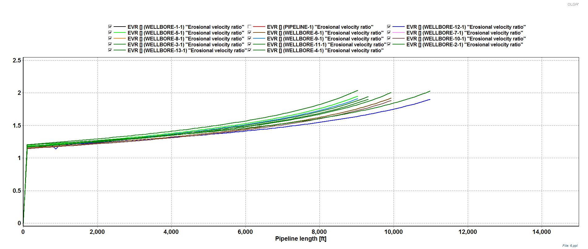
For the same separator pressure as the previous parametric studies, it can be seen that the erosional velocity in the tubing has an EVR higher than 1 in all wells. This means that in the wellbore, velocities are above the maximum erosion permitted for a 3.958 inch diameter. For this reason, the system should operate under lower velocities.
In order to solve the erosion problems, a deep study should be carried out. By performing a sensitivity analysis of the erosional velocities in the pipeline and all well tubing’s, it was found that by increasing the separator pressure and choking wells 1, 2, 4, 5, 7, 9, 11 and 13, the velocity was reduced to acceptable levels in terms of erosion velocity. The next picture explain this conclusion:

Figure 11 – Erosion velocity
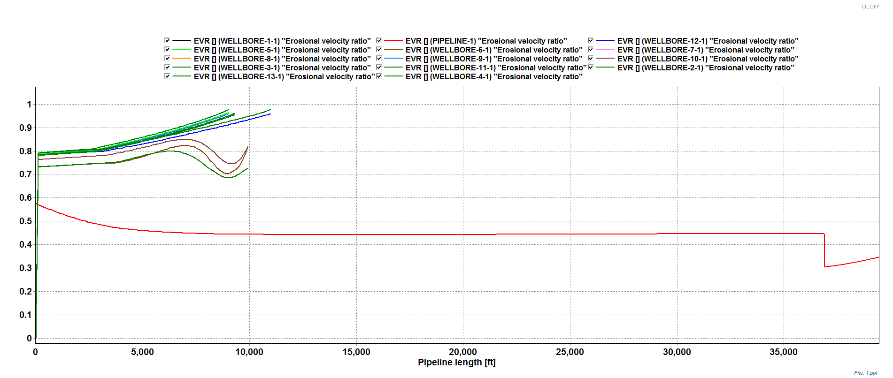

This last plot shows that all velocities, in wellbore and pipeline, verify the erosion velocity ratio criterion. The separator is set at 100 bara. The new condition will keep the tubing and the pipeline velocity below the maximum allowable.
Considering different tubing sizes, flow pattern, erosional velocities and pressure drop, the tubing size is defined as:

Table 10 – Final tubing design

Reservoir 2
Figure 12 – Oil Production
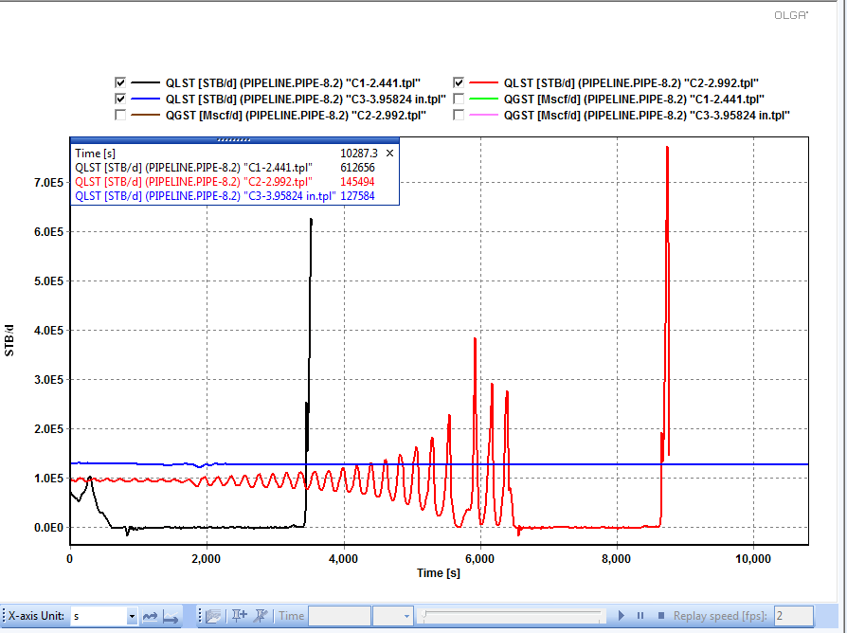
Figure 13 – Gas Production
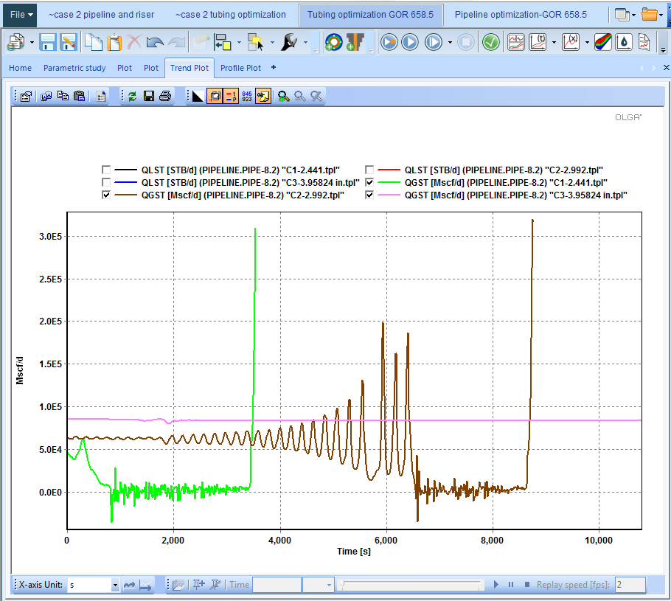
Figure 14 – Erosion velocity ratio in the pipeline
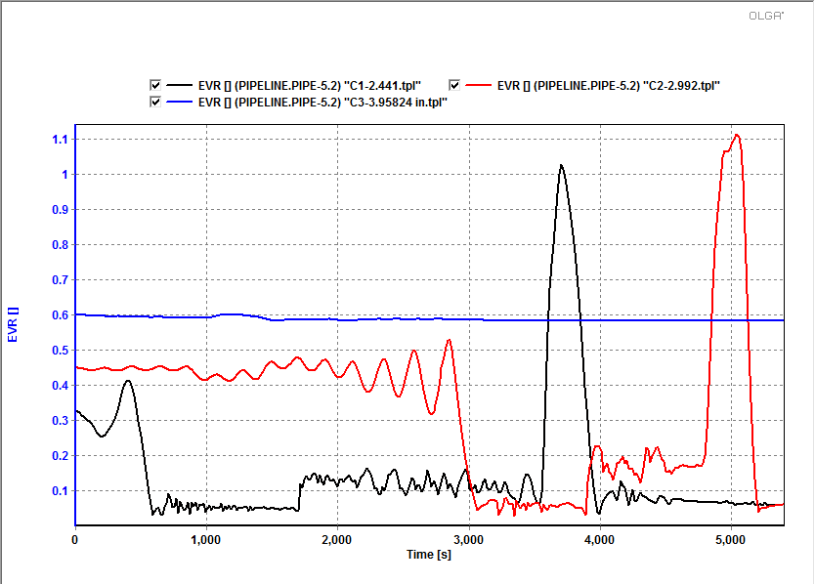
Figure 15 - Erosion velocity ratio in the wellbore tubing
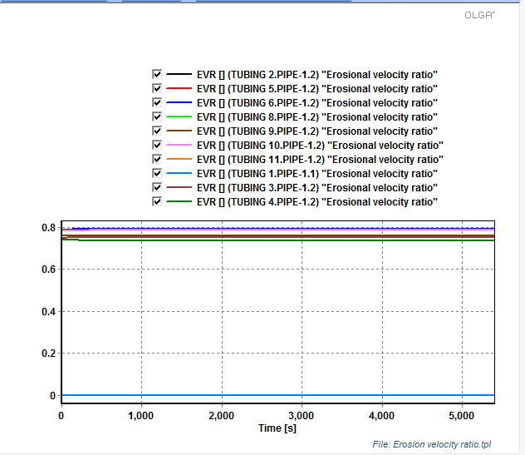
Figure 16 – Pressure drop
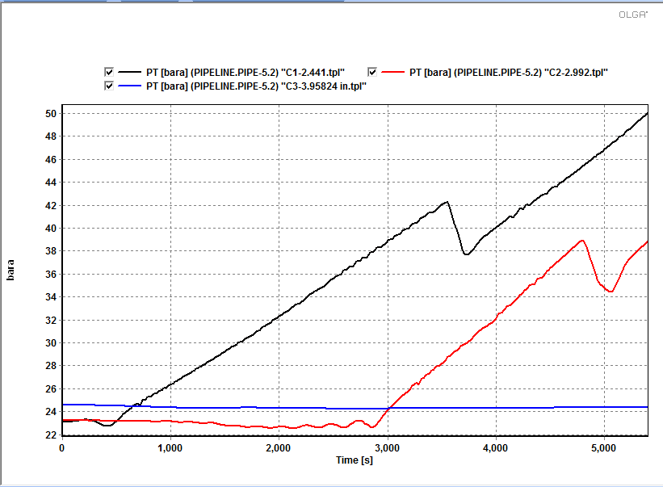
Figure 17 – Flow pattern
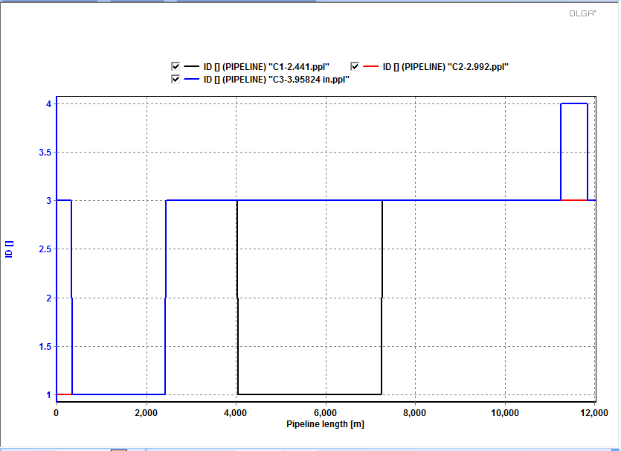
Analysis: From the above graphs it can be seen that except for the 3.928” tubing, the erosion velocity ratio tends towards 1 for other tubing sizes. Also, the pressure drop per unit length is much lower for the 3.928” tubing as compared to the other two smaller sized tubing. Slugging can be observed in all the three tubing sizes. However, most importantly only the 3.958” tubing is capable of meeting the required oil and gas production. Therefore, we select the 3.958” tubing.

Production Pipeline and Riser Selection
The diameter for the production pipeline and the riser are selected in such a way that the desired production is met while maintain a stable production rate. Also, severe slug should be avoided at every stage of the field life.
Based on the suggestions given in the table below, a parametric study was performed for different IDs given. Since the flow rate changes over time due to the effect of water cut and reservoir depletion, the selected diameter should be able to handle different flow rates from the beginning to the end of the field production. In addition, severe slugging can be avoided if the riser diameter is selected one higher to the pipeline diameter. This takes into account the Boe’s criterion for severe slugging which states that increasing the size of the riser the pressure drop in time helps in an increment in pressure drop in the pipeline relative to the pressure drop in the riser. This helps in preventing severe slugging.

Table 11 – Pipeline size
The study is performed separately for reservoir 1 and reservoir 2.

Reservoir 1
Before carrying out a parametric study, it is important to analyze the stability of the production profile.
Figure 18 – Stability of Production Profile
For this case, the sensibility used is:
Table 12 – Sensitivity Analysis
As it can be seen, for Case 1 the production is stable. Even though the highest production corresponds to Case 2, it has severe pressure oscillations. In order to control this pressure changes, a modification on the current pipeline is proposed. By analyzing the flow pattern, it can be seen that pipe-4 has a slug pattern.
Figure 19 – Flow Pattern Analysis
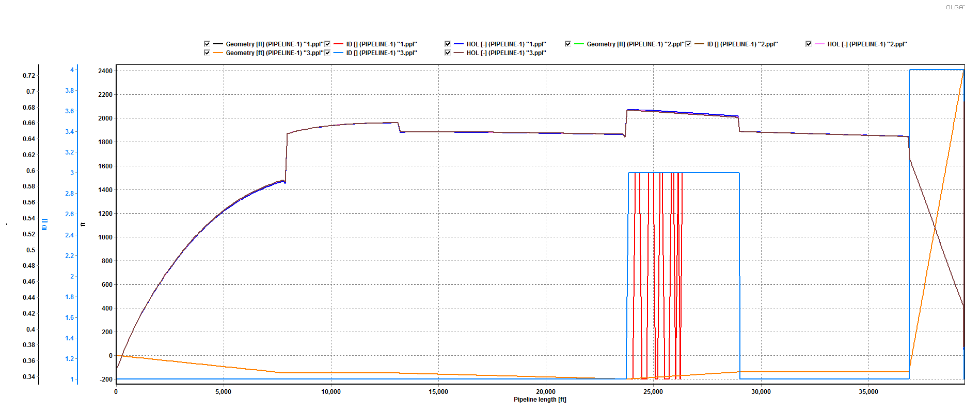
By increasing the pipe size in pipe-4 to 22.44 in, the pressure problem is solved.
Then, a parametric study was performed with a different set of pipeline and riser sizes:
Figure 20 – Pipeline and Riser Design
It can be concluded that the pipeline and riser size that optimize the field production is
Pipeline: 18.36 in ID
Riser: 22.26 in ID
Adopting the recommendation of Boe’s criterion, the riser has a larger size. Therefore the next size is selected.
Reservoir B
The results from the parametric study for different internal diameters of the pipeline for reservoir B are shown below:
Figure 21 – Oil production for different pipeline size ID
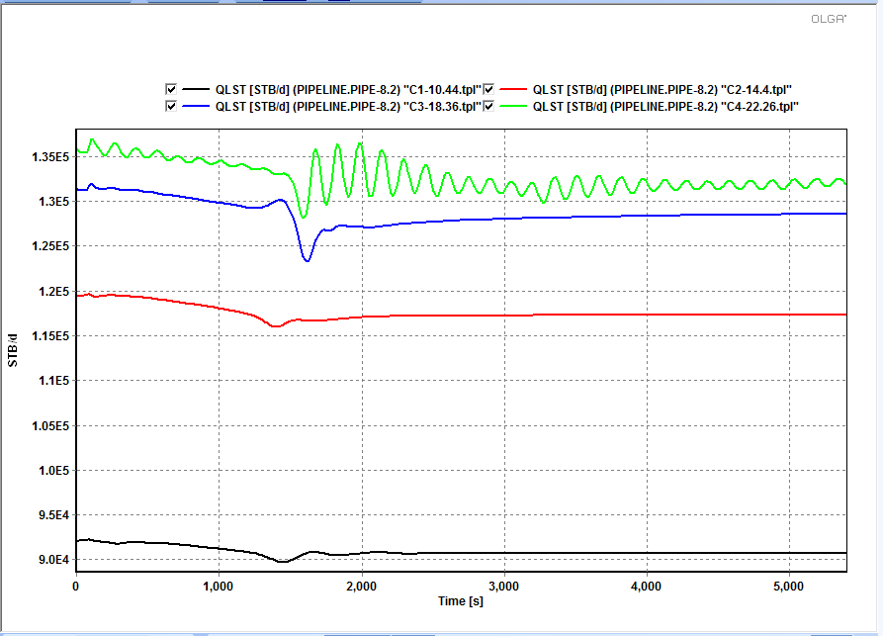

Figure 22 – Gas production for different pipeline size ID
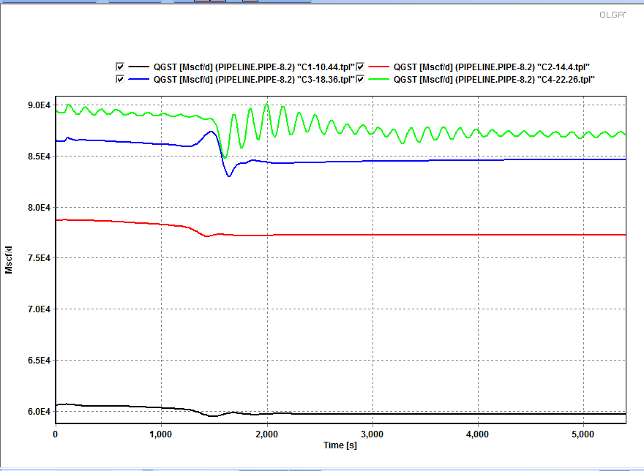
Figure 23 - HOL for different pipeline size ID
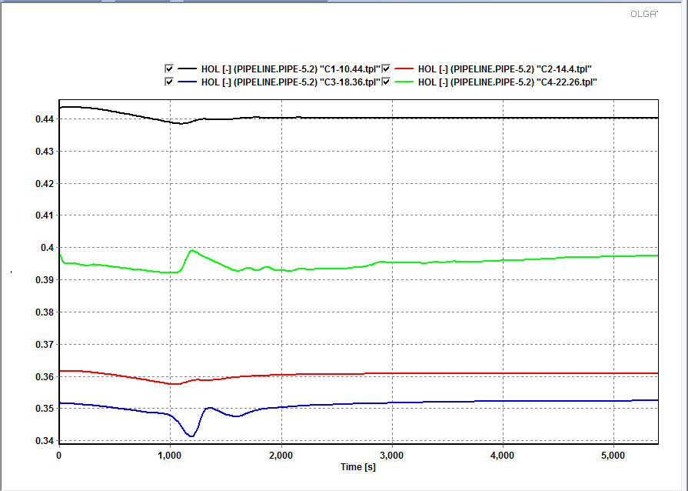
Analysis: From the above graphs, it can be seen that the pipeline with ID 18.36” and 22.26” are capable of meeting the requirements. However, the production rate is more stable for the 18.36” pipeline as compared to the 22.26” pipeline. Also, the liquid holdup is lower for the 18.36” pipeline.

Drilling Schedule
The total required production for oil is 200 MSTB/D and gas is 100 MMSCF/D. The drilling schedule for the two reservoirs has been designed in such a way that reservoir 1 meets 40% of the total production and reservoir 2 meets 60% of the total production.
Drilling Schedule for Reservoir 1
Once the tubing diameter has been defined, all surface pipes needs to be specified for its transportation. To start with, the production of each well is sent by surface lines to the general manifold. Those lines are of the same size as the corresponding tubing. Then, in the manifold the production is collected and sent to the surface through the pipeline system. A separator receive the field production and separates gas, oil and water.
The drilling schedule is defined to meet the production target, in this case 80 MSTB/D of oil and 40 MMSCF/D of gas. Therefore, several well are drilled until the desire production is obtained. The total number of wells initially on production is 15. After defining the number of wells, some parameters need to be monitored: pressure drop, erosional ratio, and stability.
Some wells were producing with instabilities on its erosional velocities calculations. Two criteria were used to solve this problem. On the one hand a high operative pressure at the separator and the use of valves to choke unstable wells and get more control of the production rate. As a result, the instabilities have been reduced and a stable production profile was obtained. .
In the next figure, the production of the first year is presented.

Figure 24 – First Year
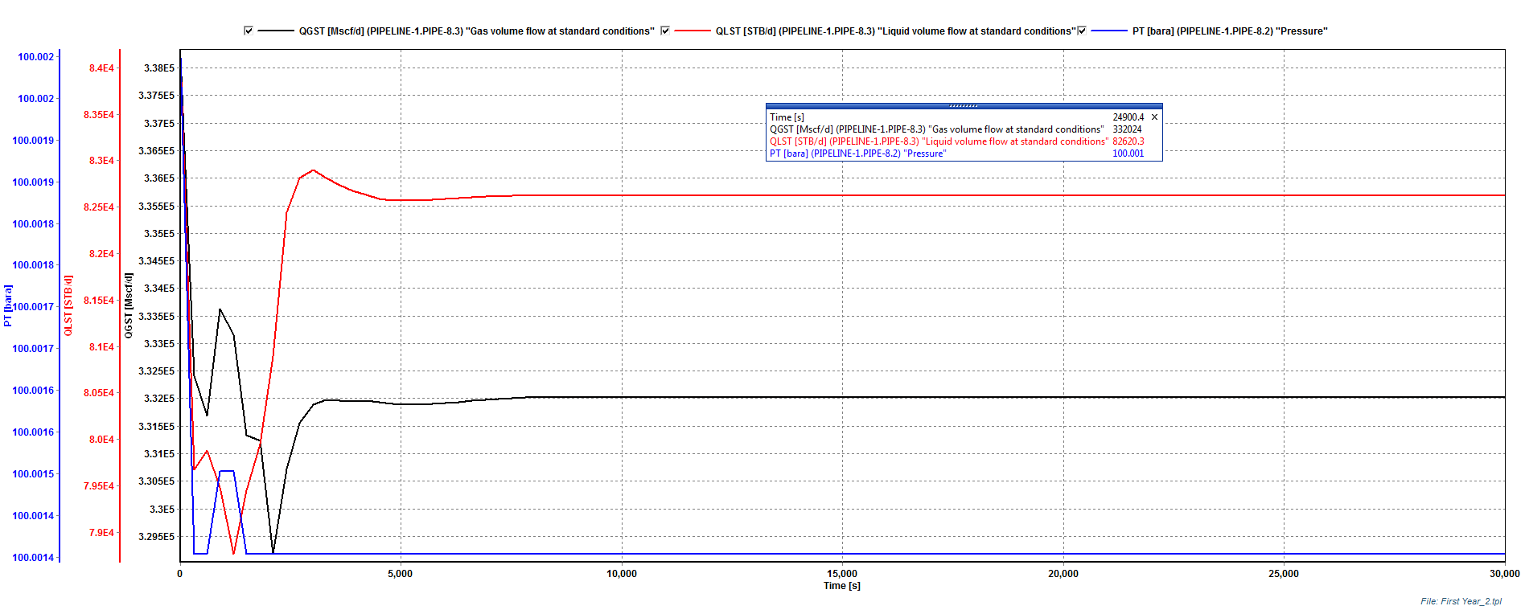
In the second year of production, the numbers of wells were kept constant and the production target was reached. The separator pressure has not changed and remains 100 psi.

Figure 25 – Second Year
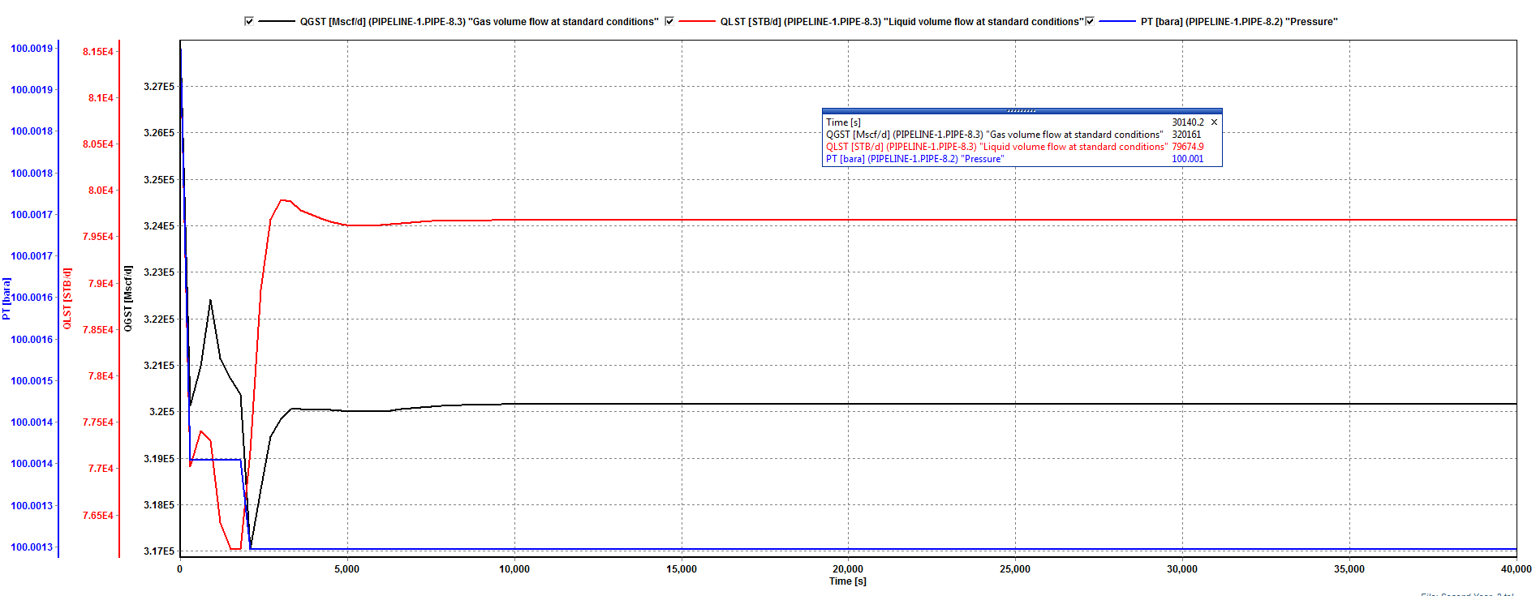
For the third year, the production has declined at a point that a new well is required. The 16th well is drilled and put on production. The separator pressure remains in 1000 psia.
Figure 26 – Third Year
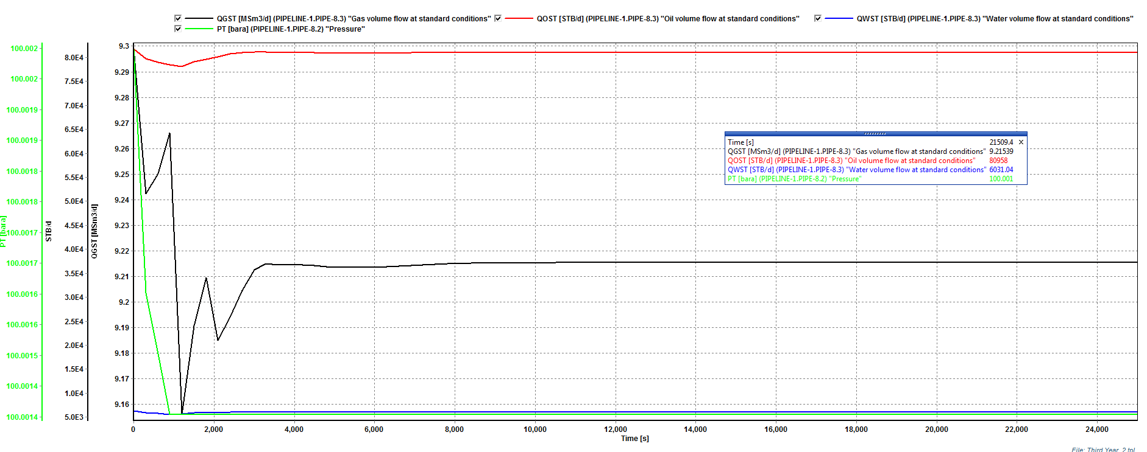
In the 4th year, the production declines below the target for this field. The water cut has increased since the third year to 8%. It means that the gross liquid production has less oil due to water content. In order to compensate the oil production, the separator pressure is reduced to 90 bara to increase liquid production from the wells. With the new separator pressure, the oil production reached the target flow rate.
Figure 27 – Fourth Year
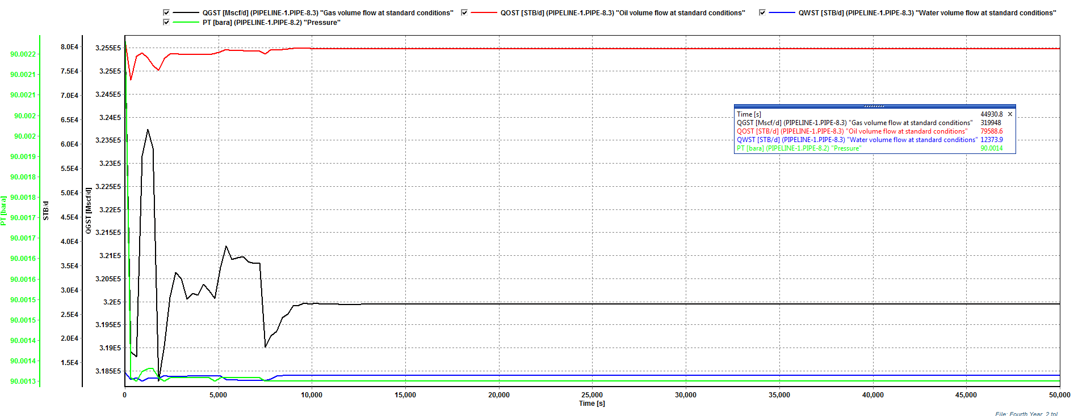
The water cut is about 8% and it has increased the gross production flow rate. At this point, it is very important to check velocity conditions in the tubing. All wells have velocities lower than the maximum admissible (EVR = 1).
Figure 28 - Erosional Velocity Ratio
In the 5th year, the water cut has reached 12%. Under this new condition, the gross liquid production should increase even more to make up oil. Thus, the separator pressure is reduced to 80 bara. The new production profile is presented:
Figure 29 – Fifth Year
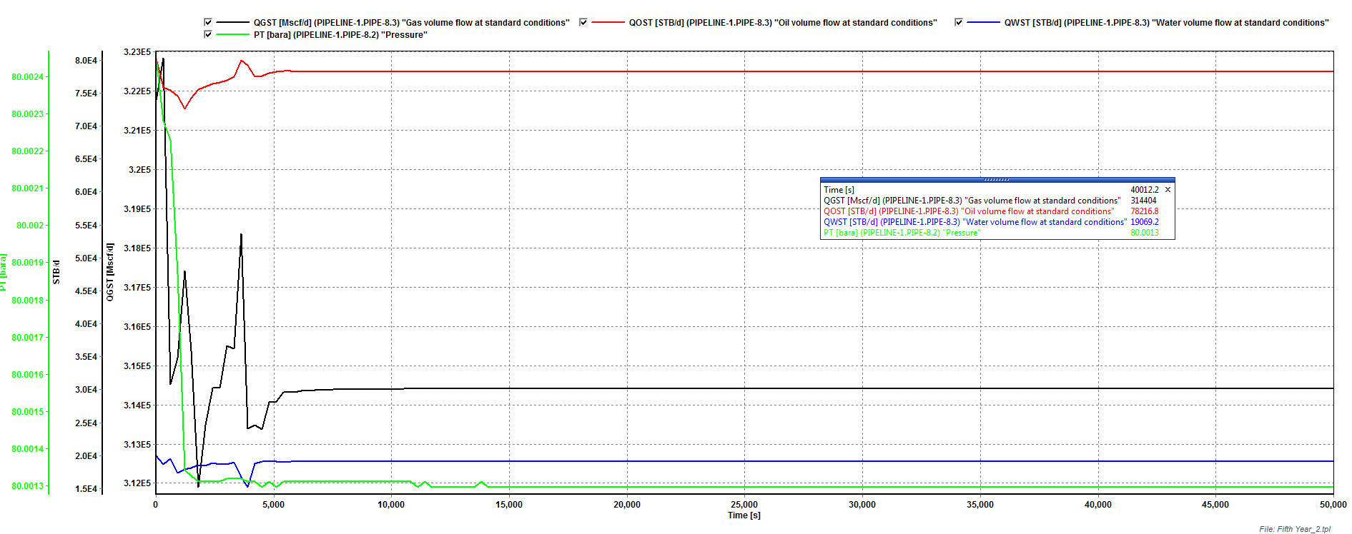
The velocity condition during the 5th year is checked in the next plot:
Figure 30 – Erosional Velocity Ratio
Even though all wells are experiencing high velocities on top, it can be consider safe within 10% of the erosional velocity.
The operating condition at the end of the 5th year is critical. By reducing the separator pressure the liquid production increases and so the velocity in the tubing. The following plot illustrates the EVR for each well:
Figure 31 – Sixth Year
As I can be seen from the previous plot, most of the wells exceed the limit of erosional velocity on half trajectory. This represent an important operative problem and is not recommended to produce at high velocities. Therefore, all wells should be shut-in.
Based on the previous paragraphs, the drilling schedule for the reservoir 1 is defined.
Table 13 – Drilling Schedule
For a field produced by naturally flow, the recovery factor (RF) is acceptable.

Drilling Schedule for Reservoir 2
The layout of the production system for reservoir 2 is shown in the figure below. The initial reservoir pressure is 6000 psia and the separator pressure is set to 10bar. The tubing diameter is set to 3.958” and the pipeline and the riser diameter is set to 20” OD and 24” OD respectively. The layout has been designed for 17 wells, however, only the required number of wells are opened for a particular year by adjusting the well head choke opening value and putting it 1.

Figure 32 - Layout of the production system for reservoir B
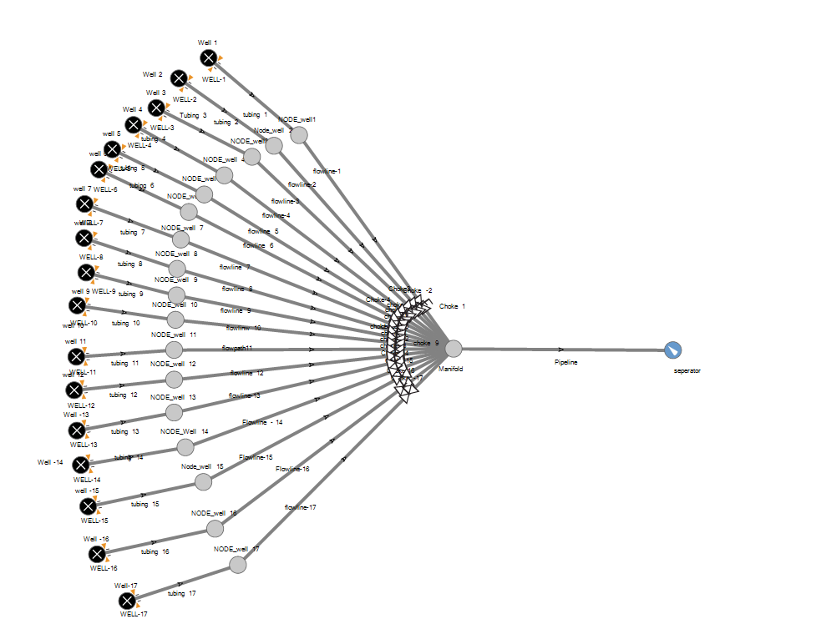

For reservoir B, the required oil production is 120 MSTB/D, while the gas production is 60MMSCF/d. Therefore, we have designed the drilling schedule in order to make sure that the number of opened wells meet the required value. After every year, the new reservoir pressure is calculated based on the decline curve analysis. The water cut has been taken into account, which is 4% for the third year and increases by 4% for every consecutive year.
Based on the above procedure, the following drilling schedule was obtained:

Table 14 – Reservoir 2 schedule
Year | Well Numbers | Qo (MSTB/D) | Qg (MMSCF/D) | Qw (MSTB/D) | P_{R} (psia)
1 | 11 | 128.774 | 84.773 | 0 | 6500
2 | 11 | 123.776 | 81.508 | 0 | 6330.8
3 | 11 | 116.585 | 76.771 | 4.857 | 6168.159
3 | 12 | 125.499 | 82.65 | 5.229 | 6168.159
4 | 13 | 126.563 | 83.354 | 101.07 | 6003.259
5 | 15 | 124.94 | 82.29 | 124.94 | 5836.956

The plots showing the oil and gas production for different years, for different years and different number of wells are shown below:
Figure 33 - Oil and gas production at the end of one year
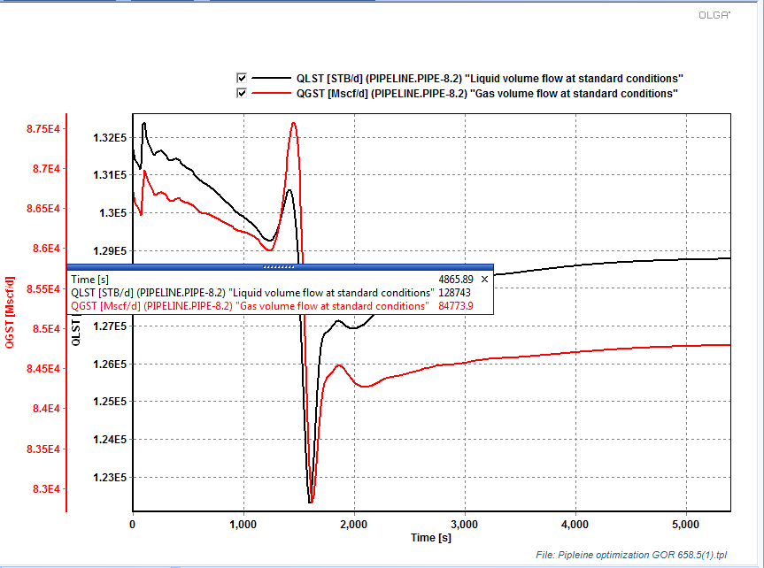

Figure 34 - Oil and gas production at the end of 2 year
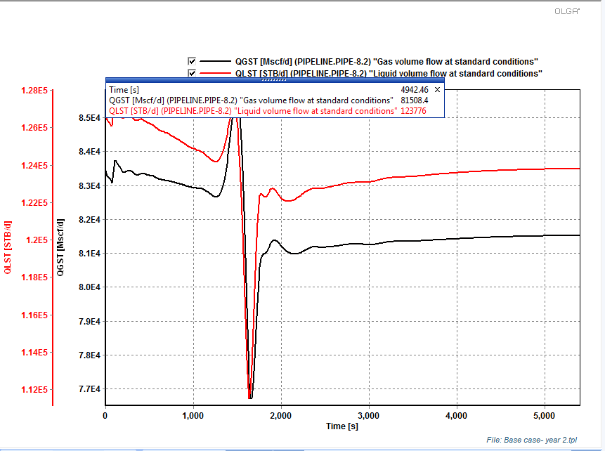

Figure 35 - Oil and gas production at the end of 3 year for 11 wells
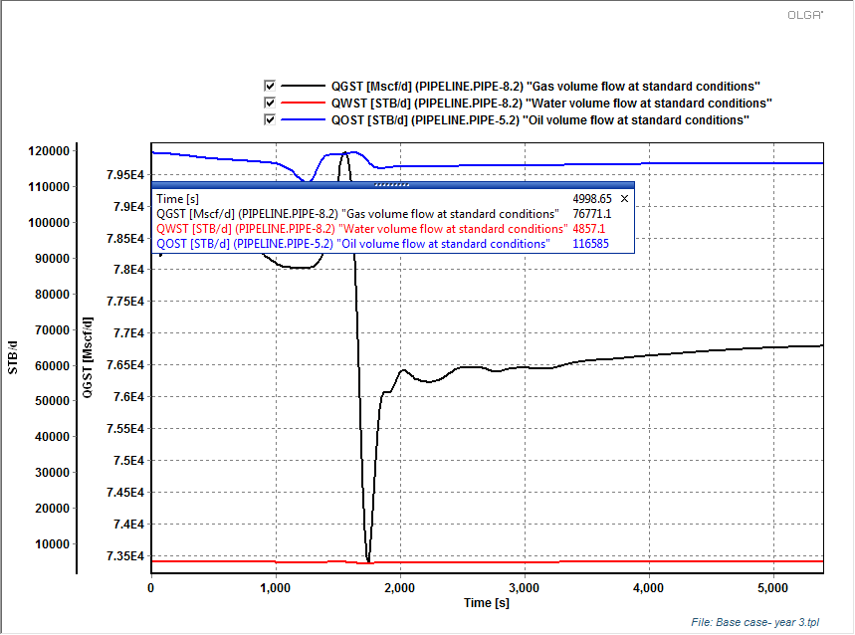
Figure 36 - Oil and gas production at the end of 3 year for 12 wells
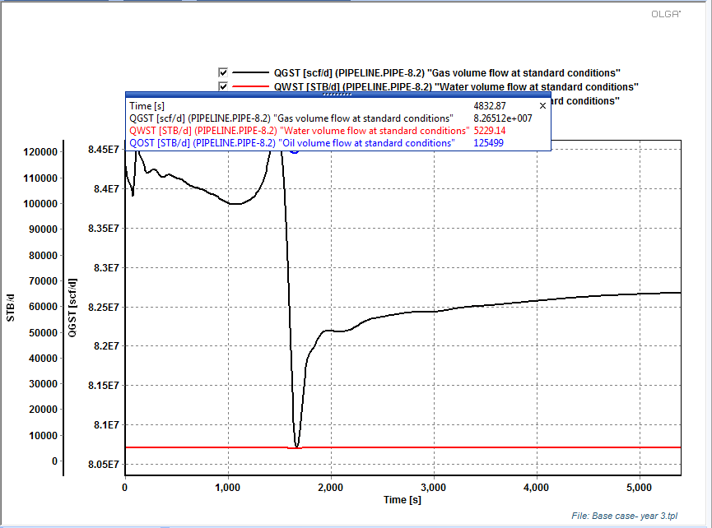
Figure 37 - Oil and gas production at the end of 3 year for 12 wells
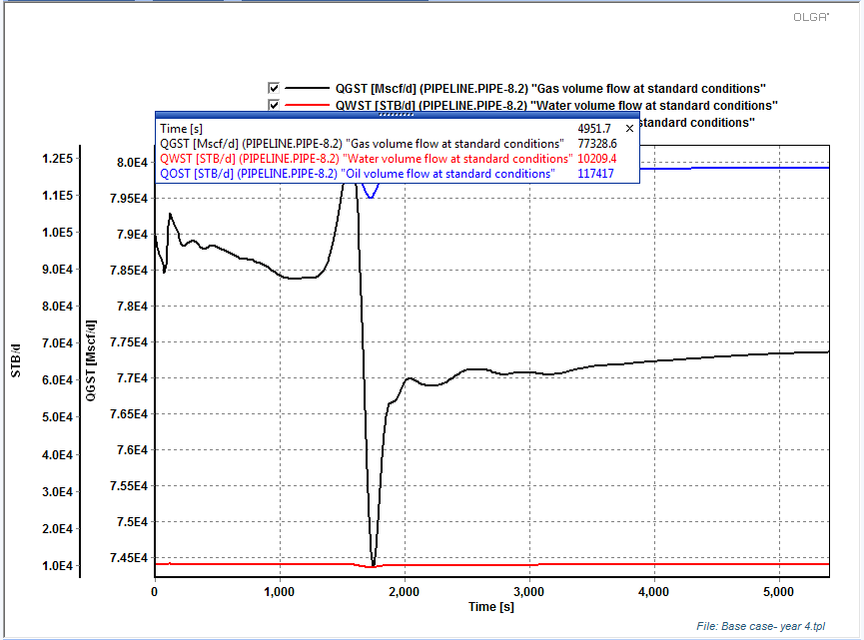
Figure 38 - Oil and gas production at the end of 4 year for 13 wells
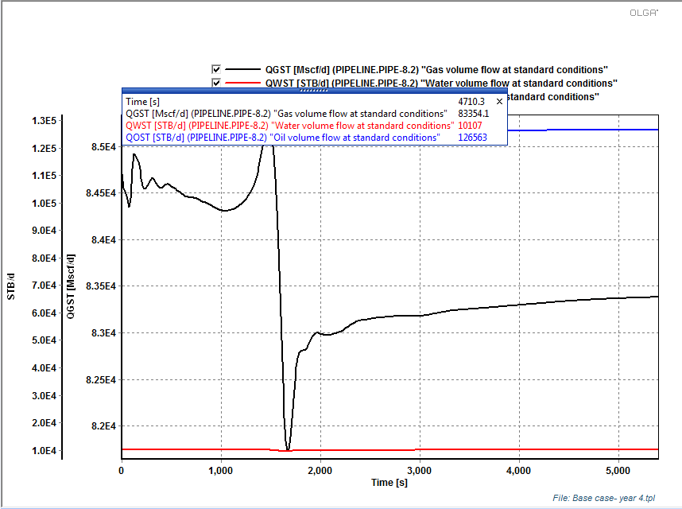
Figure 39 - Oil and gas production at the end of 5 year for 14 wells (Not sufficient)
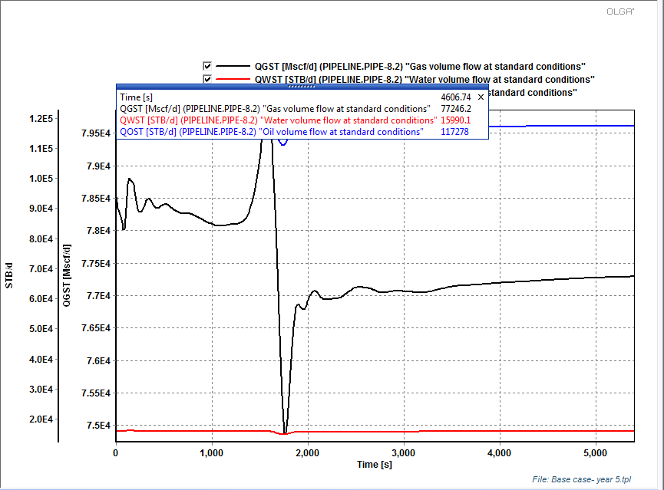
Figure 40 - Oil and gas production at the end of 5 year for 15 wells
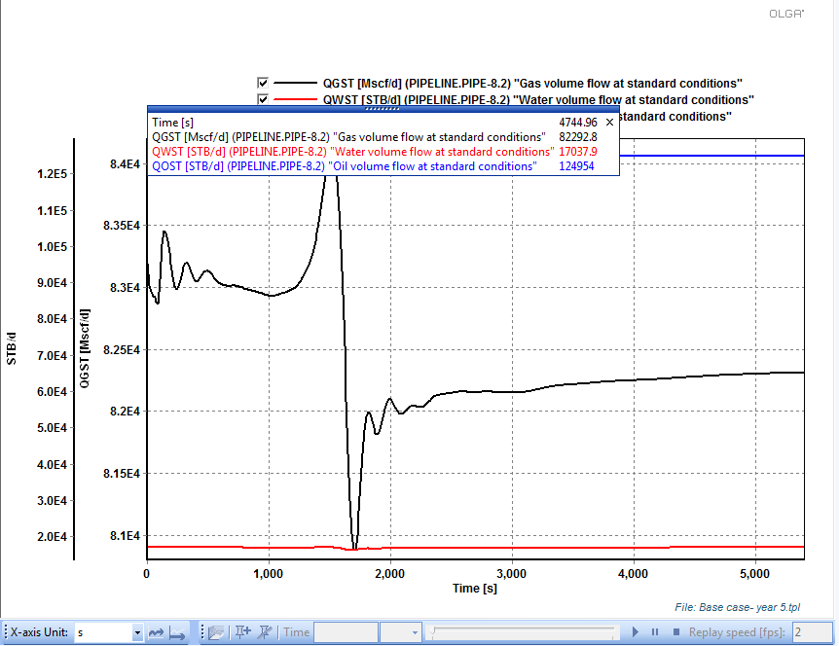
Figure 41 - Oil and gas production at the end of 6 year for 16 wells (Not meeting the required production
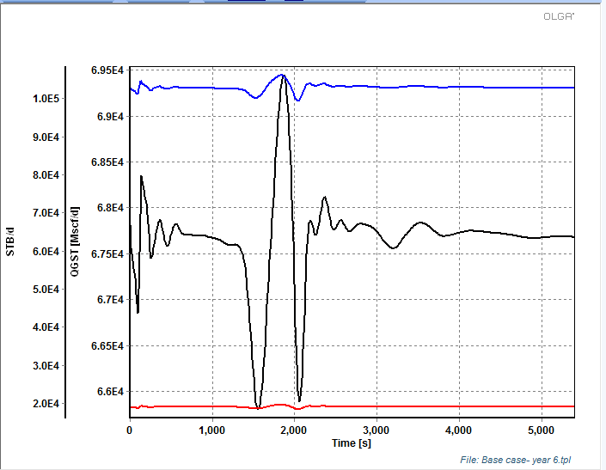

Wellhead Chokes
Reservoir 1
In the case of the reservoir 1, the effect of choke in the wellbore is not significant. This means that the VLP of the well is near its minimum point, so any change in choke yield in a small increment of production. However, chokes are used to set a backpressure in the wellhead in order to control flow velocity. Since some of the wells of the field 1 have erosional velocity issues and chokes were set to control this problem. The wells choked are: 1, 2, 4, 5, 7, 9, 11 and 13.
Reservoir 2
The effect of wellhead chokes is studied by changing the well head choke opening to different values. The simulations are performed and the results are shown below:
Wellhead choke opening 0.2
Figure 42 - Oil and gas production at the end of 5 year for 15 wells
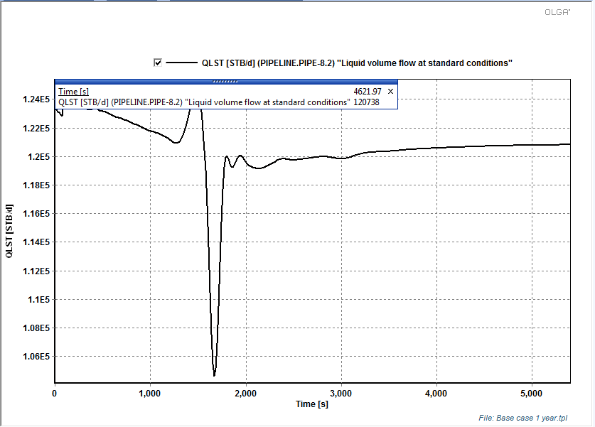
Figure 43 - Gas production for reservoir B 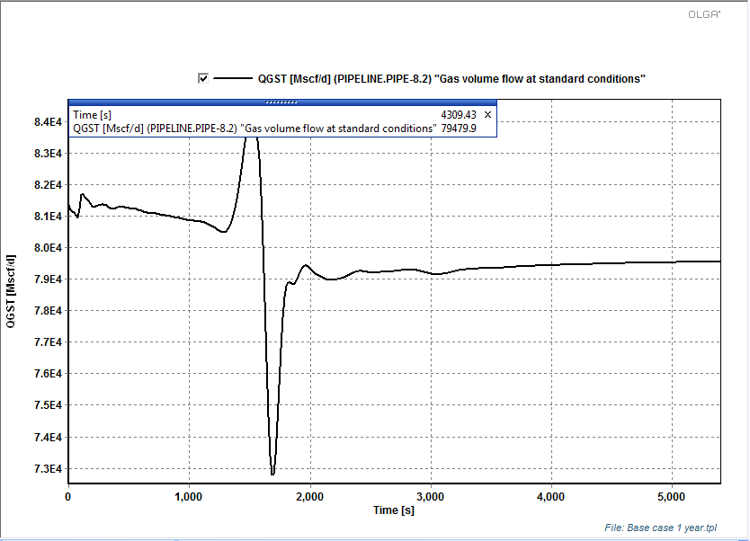
Wellhead choke opening 0.4

Figure 44 - Oil production for reservoir B
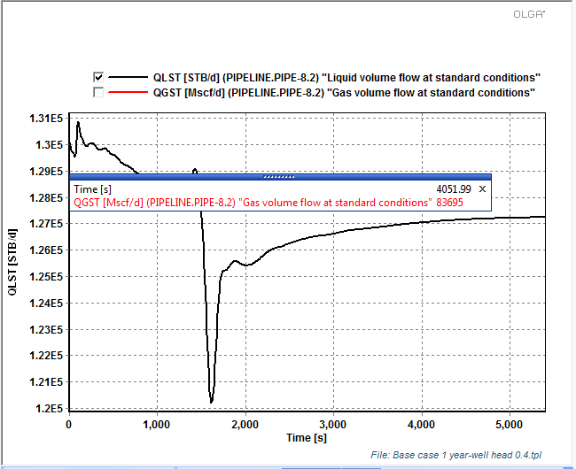

Figure 45 - Gas production for reservoir B
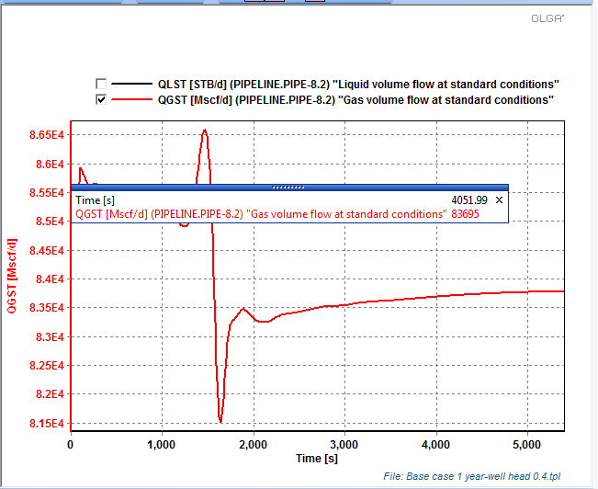
Analysis: From the above simulation results, we can see that the production increases when the choke opening is increased and the 0.2 choke opening is able to barely meet our production requirement. Therefore, it is advisable that we keep the opening 0.2 for the initial stages and gradually increase the opening to 1 as the reservoir pressure depletes.

Erosion Velocity Erosion
Care has been taken that the erosion velocity ratio is less than 1 while selection production and transportation lines. All inconvenient regarding erosional velocities were presented in the drilling schedule section.

Shutdown and Start-Up in Pipelines
The objective of this section is to generate a procedure for shutdown and start-up during a hurricane season. In all cases, the wells are going to be closed sequentially until no production is obtained. The shutdown will last 72 hours.

Reservoir 1
The idea of the shutdown is to close all wells for a period of time, while monitoring the pipeline pressure and temperature evolution. In reservoir 1, the shutdown of the wells yields to the following plot:

Figure 46 – Shutdown Reservoir 1
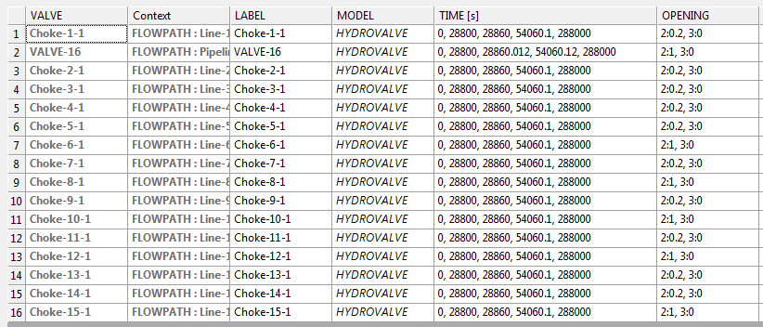

Figure 47 – Plot Shutdown Reservoir 1
As it can be seen from the last figure, a minimum of 250 mm is needed to keep temperature above WAT. If there is no possible to set this insulation thickness, it size can be reduced to combine with pigging to clean and remove paraffin. Additionally, inhibitors can be injected in the line.
In the start-up, each well are opened in groups of three during a period of time with a choke in the line. Then they are gradually fully opened.
Figure 47 – Start Up Reservoir 2
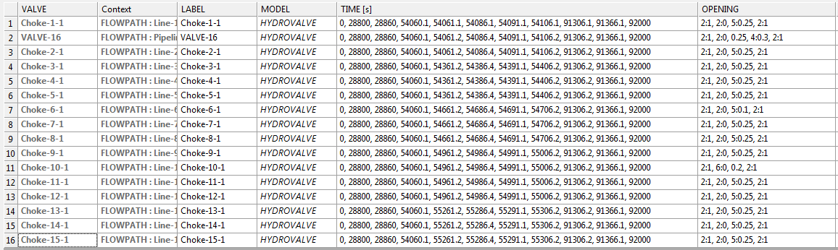
Figure 48 – Plot Start Up Reservoir 2

Transportation Line

Reservoir 1
Gas and Oil Transportation Line
For the transportation pipeline, the setup as follow:
Figure 49 – Transportation lines

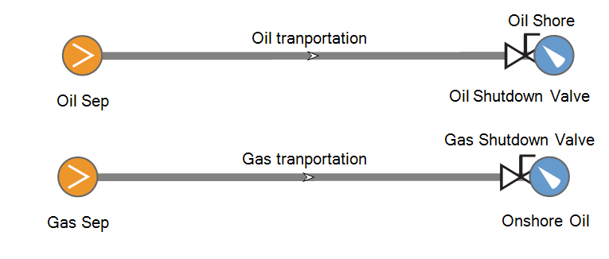
A parametric study had been done on both pipeline with different diameter to find the optimized diameter for each pipeline.

Figure 50 - Pressure profile of oil transportation pipeline with 18.36in and 22.26 inch diameter.
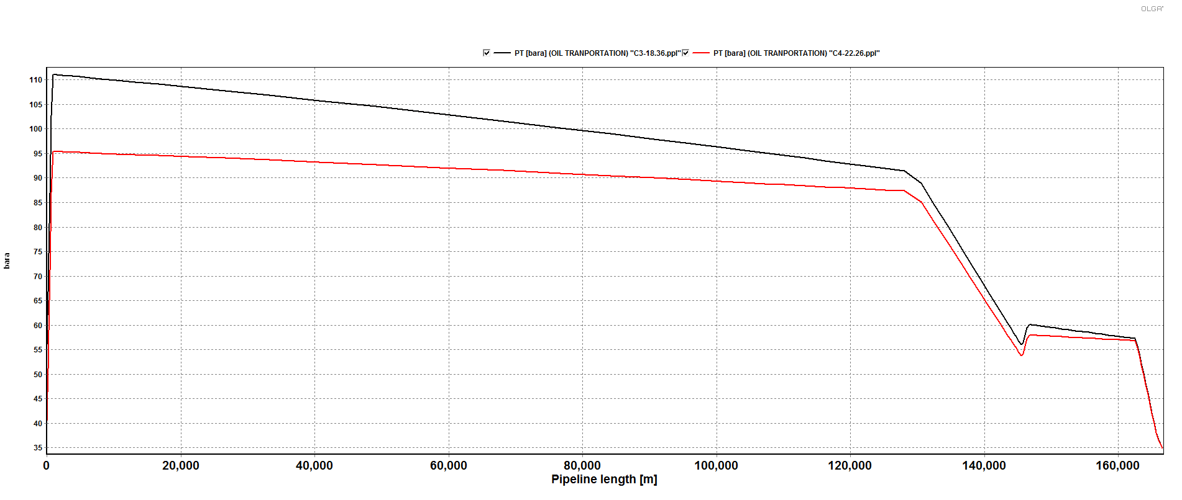
Since the required pressure is higher than the outlet of the separator, pump will be need so larger pipe to minimize pressure drop is more referable. At the end, 22.26 inch is used as the diameter for oil transportation line.
Figure 51 - Flow pattern profile of oil transportation line
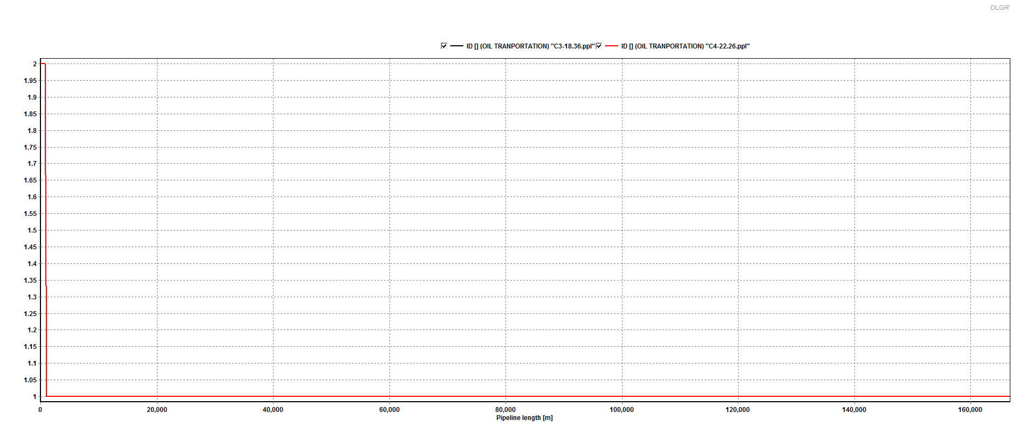
From the graph we can see there is no slug flow occurs with any choice of pipe diameter.

Figure 52 - Pressure profile of gas transportation line with 18.36 inch and 22.26 in diameter.
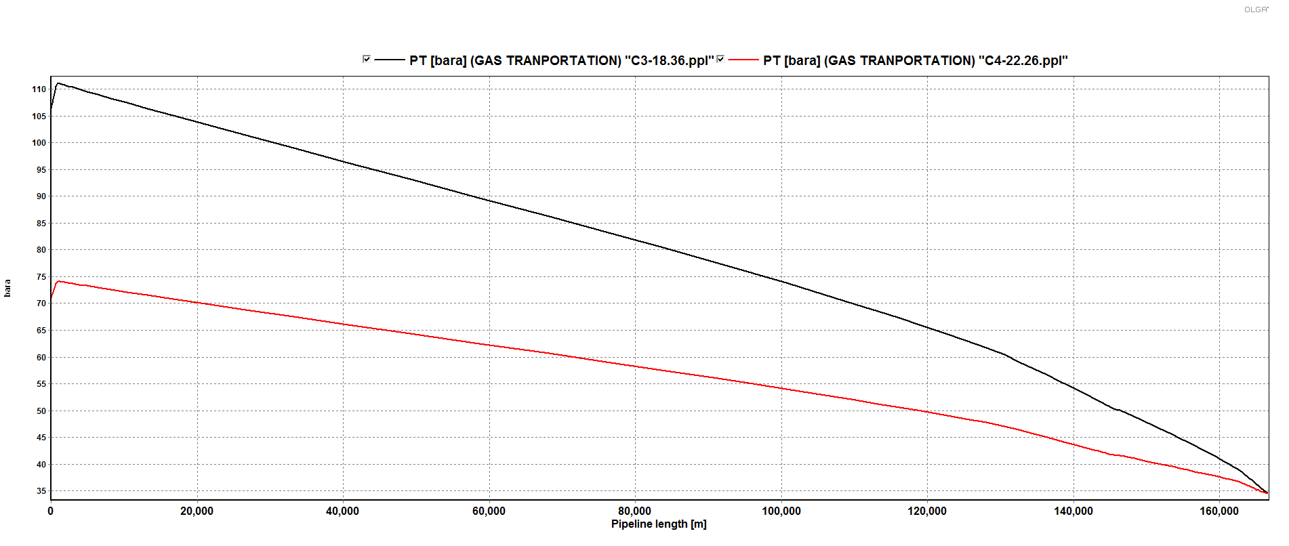
With the same reason as oil transportation line, the pressure required at inlet is higher than the pressure at separator outlet, thus a compressor is required to transport gas to the shore. Using the larger diameter pipe can have to minimize the pressure required from compressor so 22.26 inch is chosen for gas transportation diameter.

Reservoir 2

Oil transportation line:
A parametric study has been done for different internal diameters to select the pipe diameter.
The maximum flowrate was selected to conduct the study. The pressure on shore is set to 500 psia. The fluid file used is LiaMix.tab. The pressure profile, temperature profile and flow pattern was selected as the basis for selecting the pipe diameter. The graphas obtained after running the simulations are shown below:

Figure 53 - Pressure profile for different IDs
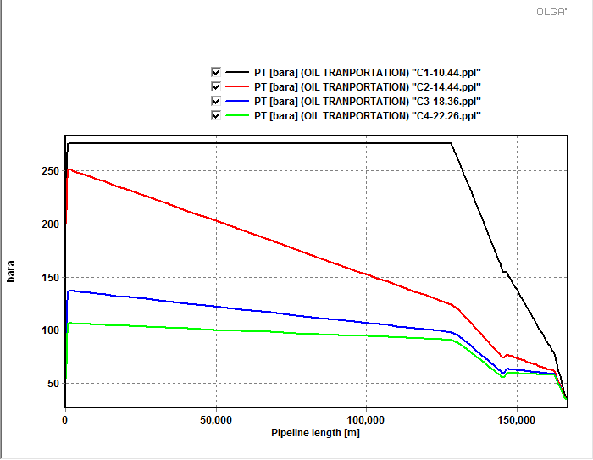
Figure 54 - Temperature profile for different IDs
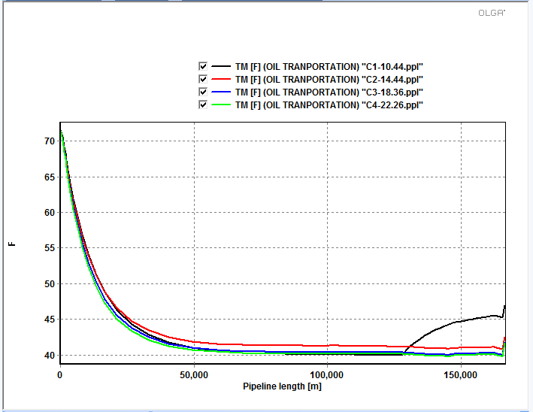

Figure 55 - Flow pattern (No slugs are observed for any case)
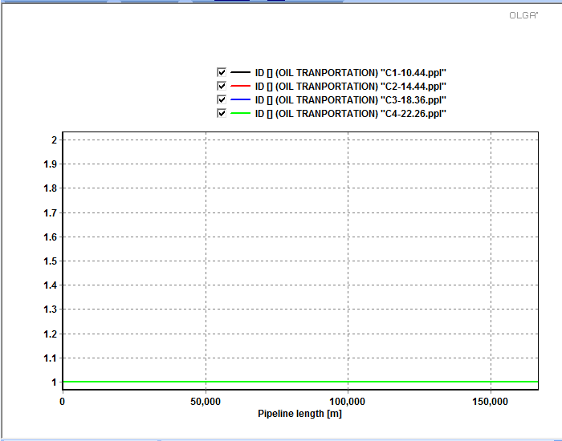
Analysis: From the above graphs, it can be seen that the most influential parameter is the pressure drop is minimum for the 22.26 in pipeline. Therefore, we select that as the pipeline diameter.
Gas transportation line:
A parametric study has been done for different internal diameters to select the pipe diameter.
The maximum flow rate was selected to conduct the study. The pressure on shore is set to 800 psia. The fluid file used is VaporMix.tab. The pressure profile, temperature profile and flow pattern was selected as the basis for selecting the pipe diameter. The graphs obtained after running the simulations are shown below:

Figure 56 - Pressure profile in the gas transportation pipeline 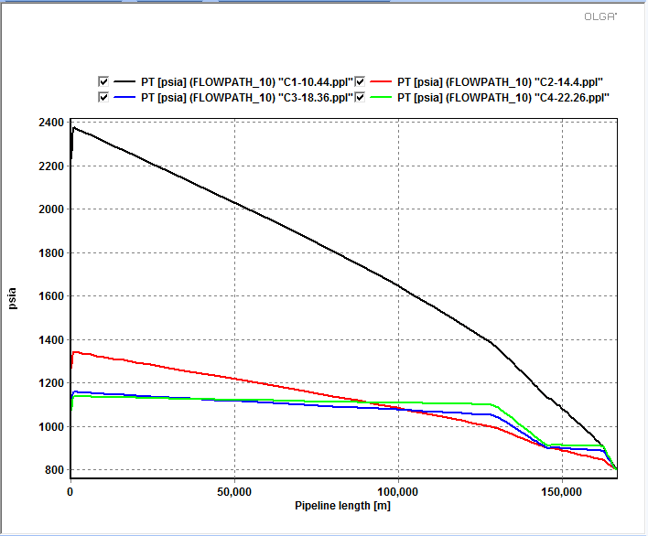

Figure 57 - Flow pattern
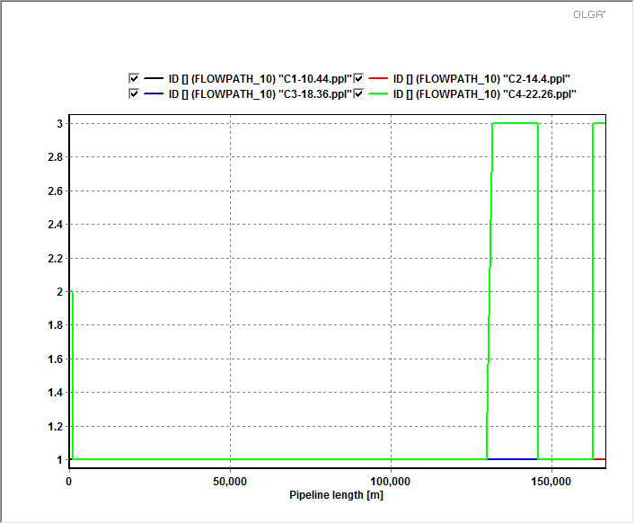

Analysis: From the above graphs, it can be seen that the pressure drop is very high for the smaller 14.44 in pipeline while it is low for the higher diameter pipelines. However, it should be noted that a lot of slugging is observed in the pipeline with 24 in diameter. Therefore, we should an optimum pipeline of 18.36 in internal diameter and 20 in external diameter for o gas transportation pipeline.

Flow Assurance
Flow Assurance is a very important consideration in production design systems. Wax deposition occurs when the temperature of the fluid at the wall falls below the Wax Appearance Temperature. Hydrate formation takes place when there is free water present accompanied by low temperature and high pressure conditions. Therefore, in our case the wax deposition problem should be addressed in the production pipeline as well as the transportation pipelines. Since there is water in the production pipeline from the third year onwards, we need to check for the hydrates formation. Since, the water is drained out directly after the separator, there is a lesser chance of hydrate formation in the oil and gas transportation pipeline. However, since the temperature drops significantly there might be some condensate in the transportation line. Therefore, it is advisable to check for both wax deposition and hydrate deposition in the transportation pipeline.
The shut-in and start up procedures are the most critical for wax and hydrates deposition. This happens mainly because of the liquid accumulation. If we are able to avoid wax deposition and hydrate formation during the shut-in and start-up period, then we can have a safe production during other stages.

Wax Deposition:
Reservoir 1
According to PVTsim, the WAT of the oil is:

Figure 58 – Reservoir 1 WAT
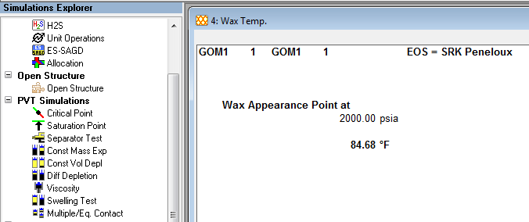

Reservoir 2
The Wax Appearance Temperature is calculated from PVT. The WAT for fluid in reservoir B is 84F as shown below:
Figure 59 – Reservoir 2 WAT
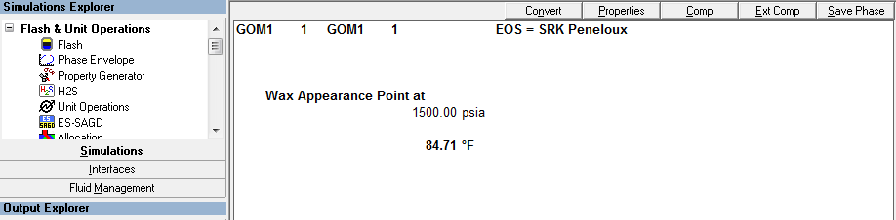

Wax deposition in oil transportation line
Reservoir 1
The temperature at separator outlet is too low 42F, so the whole system would be under wax deposition. Heat at the inlet is preferable to minimize wax in pipe line. For simulation, input fluid have been heat up to 175F at entrance and we have following results:

Figure 60 – Temperature and pressure profile of oil pipe line

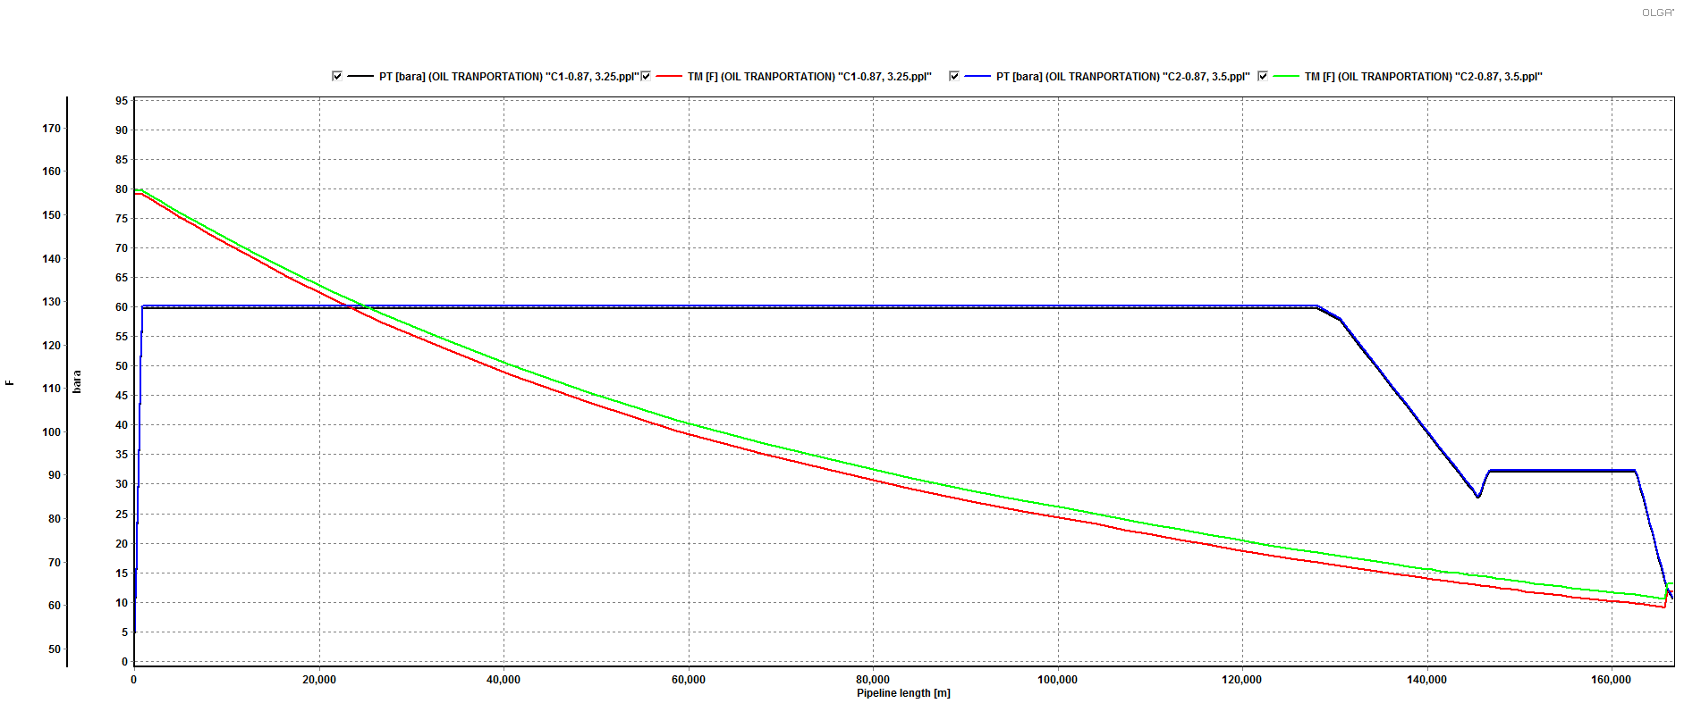

At working condition, at the end of pipe line still under WAT and likely to have wax deposition. The change from 3 in to 3.75 in thick ness of insulation is not affect much so it likely due to the expansion of gas in upward flow. Then wax de position would still affect the pipeline in working condition. Pigging is suggest to solve this problem. Insulation and heat up at the entrance can have to keep wax region only near shore so pigging would be more economical. At this point forward, both pipeline use 3ich insulation and get heat up before entrance to 175 F.

Figure 61 – Temperature and pressure profile after 72hrs shut down
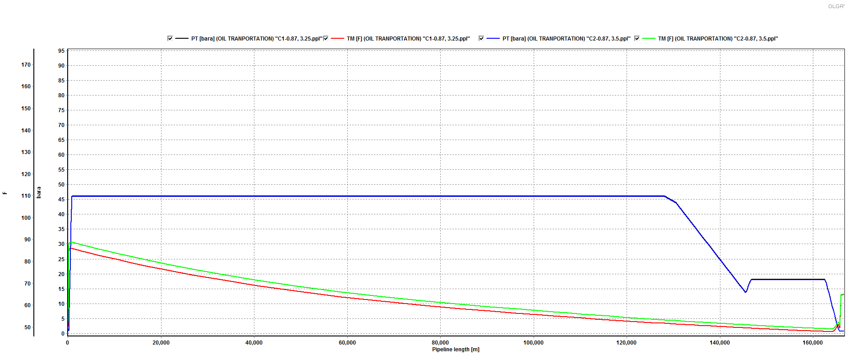

From Graph above the whole system would form wax after 72 hours shut down, the insulation is not really effective so at the startup, flow hot fluid to remove wax is better than increase on insulation.
From shutdown and start up procedure, we will occur high pressure in front of the valve at shore end. Since the oil line would be full of oil in riser and pipeline, that could cause the Pressure build up in front of valve. Depressurizing pipeline is necessary and also can help to reduce wax deposition.
For shut down procedure, we close valve after shut down 1 hour to depressurized pipeline. For startup procedure, shut down valve would be open 5 minutes before flow start to depressurized gas cumulative in front of valve.

Reservoir 2
A parametric study was performed with different insulations. The results are shown below:

Figure 62 – Temperature profile for different insulation

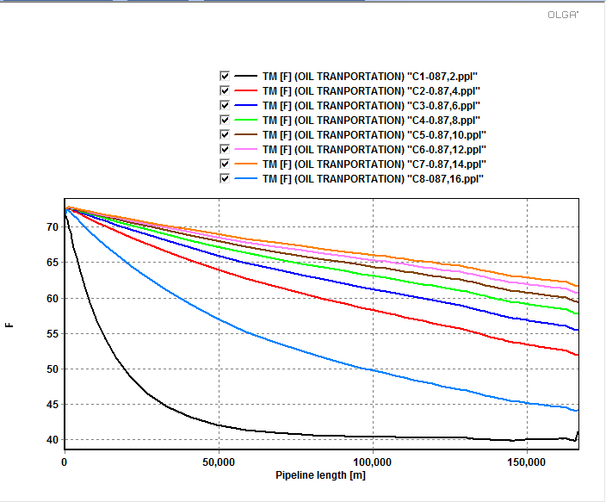
Analysis: It can be seen that the temperature is below WAT for different insulations. Therefore, there is a need to adopt other methods for wax formation prevention. However, in order to minimize the temperature drop, we can use the 10 in insulation. We can use mechanical pigging to remove the deposited wax. In order to reduce the frequency of pigging, we can also use electrical heaters at the beginning of the pipeline if it is economical.
Wax deposition in gas transportation line
Reservoir 1
Figure 63 – Temperature profile for different insulation
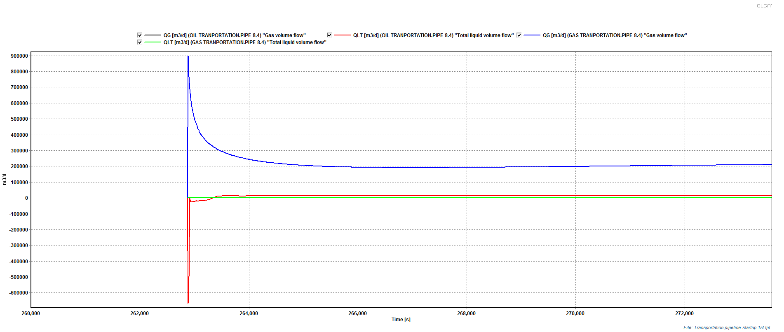
Flow rate in gas pipeline and oil pipeline vs time after start up.
From graph above, a large surge of gas would come in at the beginning of startup, to avoid that, depressurized should also done on gas pipeline. Closing valve after shut down 2 hours to depressurize the system, we can avoid te problem.

Figure 64 – Flow rate in gas pipeline and oil pipeline vs time after start up with de pressurizing
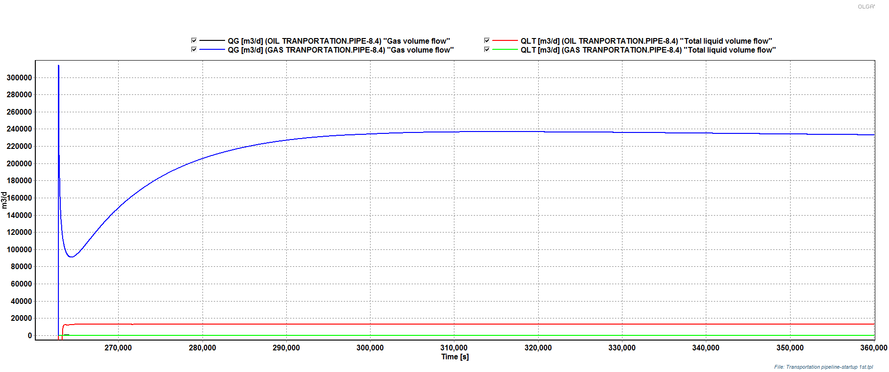
Reservoir 2
A parametric study was performed with different insulations. The results are shown below:
Figure 65 – Temperature profile for different insulation
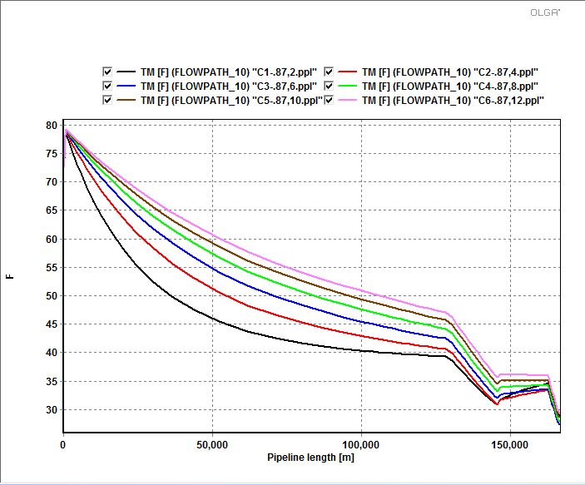
Analysis: It can be seen that the temperature is below WAT for different insulations. Therefore, there is a need to adopt other methods for wax formation prevention. However, in order to minimize the temperature drop, we can use the 10 in insulation. We can use mechanical pigging to remove the deposited wax. In order to reduce the frequency of pigging, we can also use electrical heaters at the beginning of the pipeline if it is economical.

Wax deposition in the production pipeline during shutdown:
Reservoir 1
In order to avoid paraffin deposition, insulation is taken into account for pipeline. Furthermore, the minimum thickness that allow to get a temperature above WAT is 250 mm. The following plot describes the analysis. It consist of a shutdown of 72 hours.
Figure 66 – Temperature Profile in Pipeline
In case 250 mm does not result a practical operation, a second option consist of a reduced insulation like 50mm followed by pigging every shut down. With this, wax deposition can be easily handled in a pipeline.

Reservoir 2
The wax deposition study was performed during the shutdown period. A parametric study was conducted to see the effect of changing the insulations in the pipeline. The results of the simulations are shown in the figure below:

Figure 67 – Temperature profile in the pipeline for different insulation
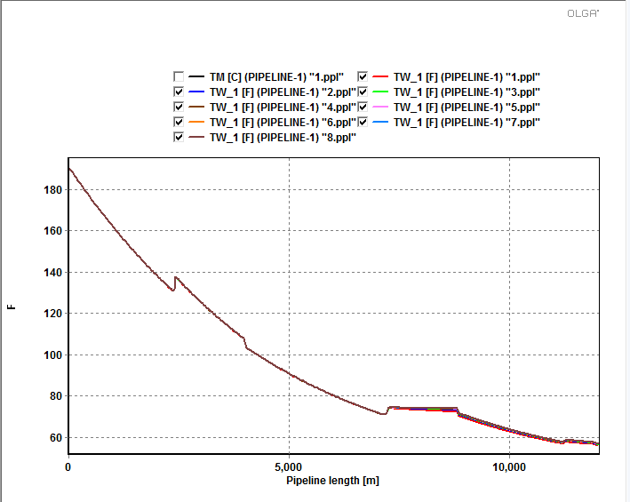
Analysis: It can be seen that the temperature drops below WAT after a certain length of the pipeline and mainly in the riser. To prevent this, we can add chemical inhibitors or we can use mechanical pigging to remove the deposited wax.

Three Phase Separator
From beginning, second part of simulation include separator in the platform and pipeline to shore. Following set up is the original:

Figure 68 - Set up for separator and pipeline in year 1 and 2 before water introduced to system

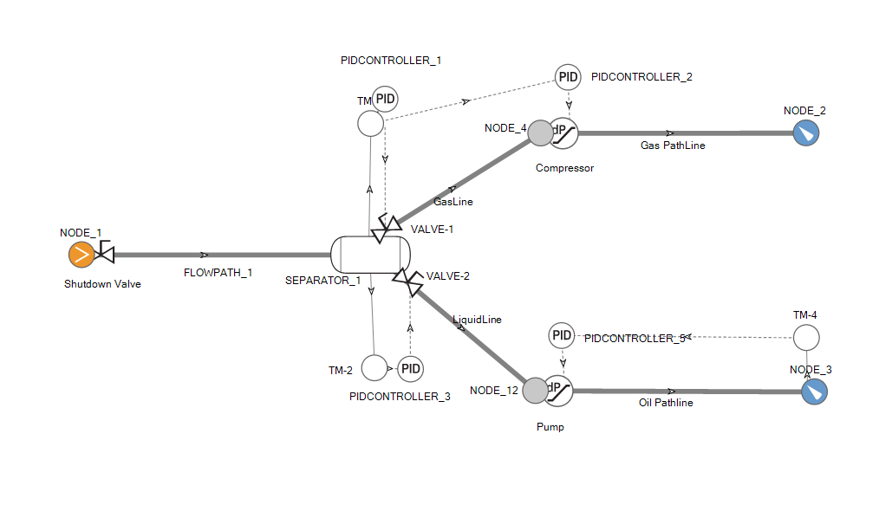

Figure 69 - Set up for Separator and pipeline from 3rd year forward
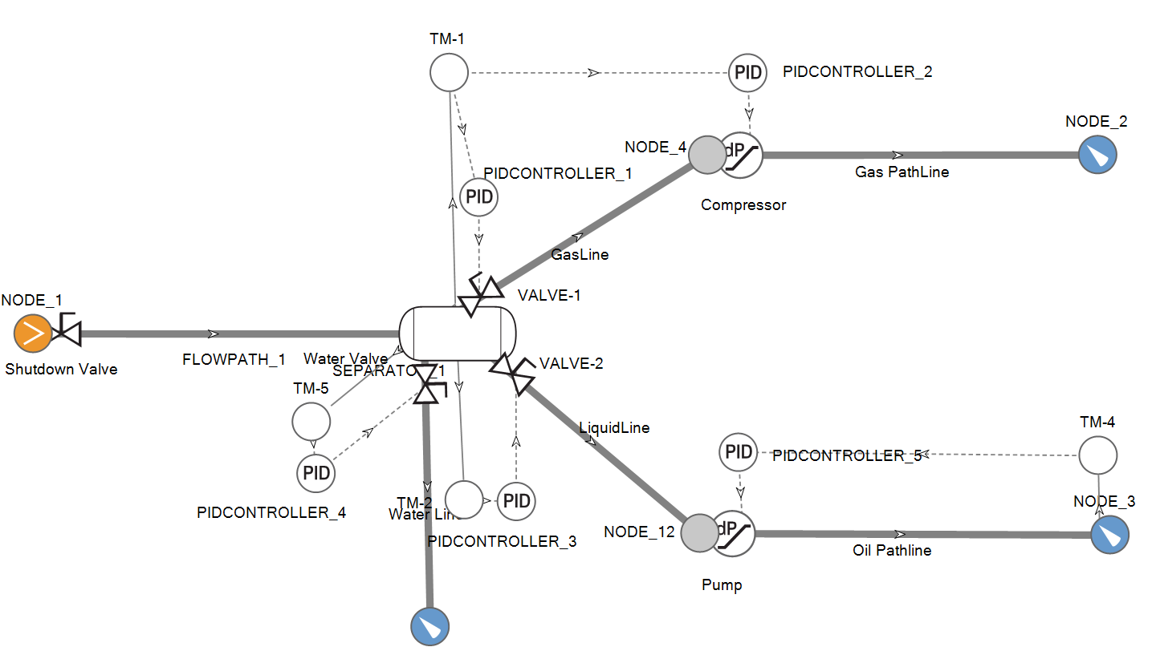

Since this set up take in account of many variable from PID Control, The time to run the whole system can take hours to a day. With this time consumption, the second design which is separate of the separator and pipeline as following is used with the mass flow at separator outlets is the inlet of mass flow node of pipeline and the phase is used as Gas for gas line and Oil for liquid line.

Figure 70 - Set up for separator setting for 2 first years

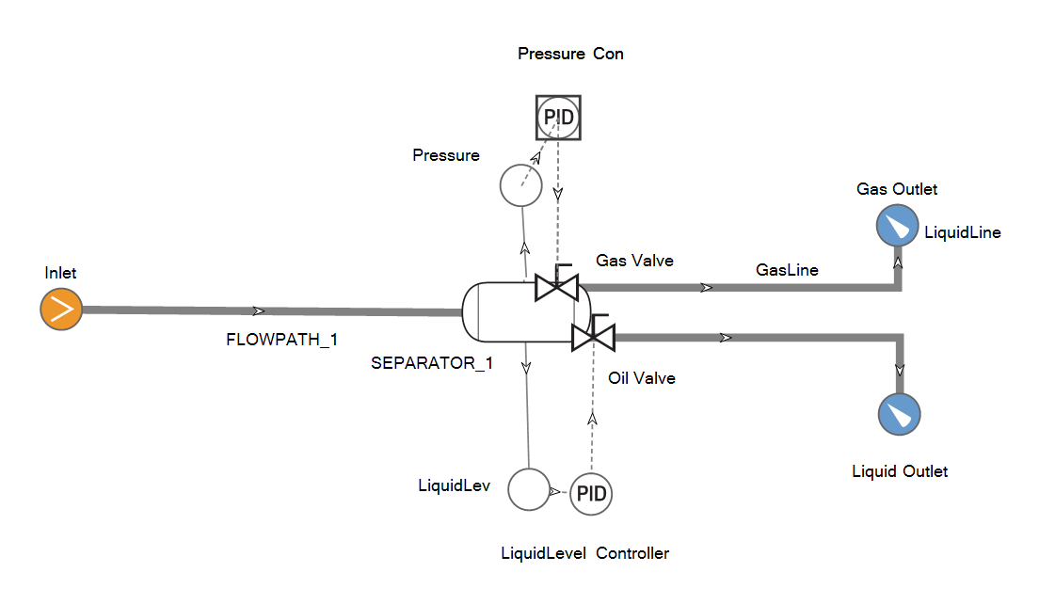

Figure 71 - Set up for separator setting

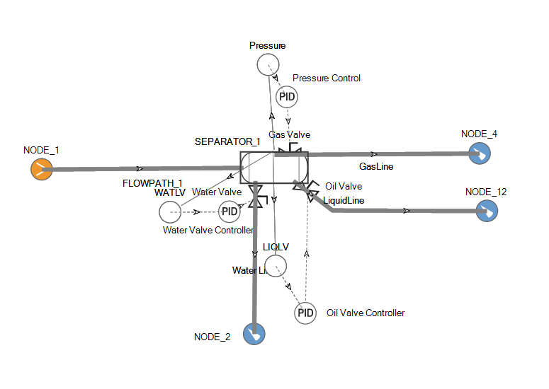

Pressure and liquid level of separator is controlled by the gas valve and Oil Valve. The following is the result of separator simulation.

Figure 72 - Separator Pressure and Liquid level trend graph
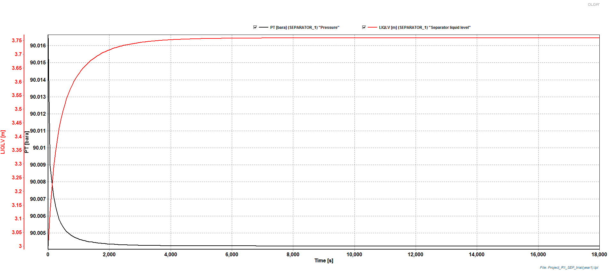
Using mass flow at separator outlet to mass flow node in pipelines simulation, running parameter study for liquid pipeline as below.

Appendix: Design Project Statement
A new offshore oil field has been discovered in GOM. Seismic studies and well tests suggest two adjacent but isolated anticline structures, with possible reserves of 0.72 Trillion SCF of natural gas and 1.8 billion barrels of oil for the first structure, and 1.4 Trillion SCF of natural gas and 2.0 billion barrels of oil for the second structure. The field is located approximately 100 miles offshore where the water depth is 2,500 ft.
A preliminary design study is required to determine the feasibility of developing the field. The study should be based on the assumption that a single platform can accommodate the two areas with up to 32 wells. Fluids from each well will flow through a wellhead choke and into a manifold. The fluids leaving the manifold will flow through pipelines and risers to the platform where separations take place. Then, the water is dumped to sea after treatment. Gas and oil (equilibrium corresponding to the separator condition) are flowed through individual pipelines to shore. When the field is no longer naturally capable of producing the desired rate, compressors and pumps will be used to increase well flow rates to the desired level and elevate platform pressure enough to transport the fluids to shore. The arrival pressure at shore is set as 800 psia for gas and 500 psia for oil. It is required that at least 100 MMSCF/D gas and 200 MSTB/D oil from the field are produced.
Your design study should use OLGA for the calculations and consider at least the following aspects.
- What diameter(s) of tubing should be used in the wells, and why?
- What drilling schedule should be used for new wells to sustain the desired production rate for the field?
- Should wellhead chokes be installed, and if so how should the choke settings change with time?
- What diameters of the pipelines and risers should be used, and why?
- What diameters of the transportation pipelines from platform to shore should be used, and why?
- Will compression and pumping be required on the platform? If so when and what capacities are needed?
- Do the liquids in the gas transportation pipeline pose a problem? If so, what remedial actions do you suggest? Consider pigging (If you recommend pigging you need to provide a pigging program considering the recovery of the liquids onshore with a slug catcher), and other alternatives.
- Water appears in production from the third year (4%) and increases 4% every year thereafter.
- Consider a 72 hour shut-in due to a hurricane and develop the shut-in and restart procedures.
- Erosion problems should be avoided.
- Flow assurance issues such as Wax deposition and Hydrates formation should be considered.
- When will the field no longer be capable of producing the desired gas volumes? What production schedule could be maintained after this time?

RESERVOIR DATA
The reservoirs can be assumed to be isothermal at 250°F and 270°F, and have an initial pressure everywhere of 6,000 psia and 6500 psia, respectively. The inflow performance equation is assumed to be linear:
where , . The pressure decline curves for the two reservoirs can be described by the following equations:
for reservoir 1,
for reservoir 2,
where is the cumulative volume (in STB) of oil produced from the field and is the average pressure in the field.

FLUID CHARACTERISTICS
The discovery wells produced fluids from the two reservoirs with the compositions listed in the PVTsim fluid files.
WELLBORE AND PLATFORM CALCULATIONS
The field will be produced with up to 32 wells (you may add more if necessary) drilled directionally to provide appropriate well spacing in the reservoir. For simulation purposes, these wells can be considered to fall into four categories. The first reservoir depth is assumed as 8000 ft from sea bed and the second reservoir 10000 ft. The inclination angle (from horizontal) and approximate percentage of the total wells for each category follow. You can assume appropriate outside heat transfer coefficient for the pipelines and risers. The sea bed temperature is 40°F and sea surface temperature 65°F.

Category | ❑ (°) | % of wells
A | 85 | 25
B | 75 | 25
C | 65 | 25
D | 55 | 25
The following information describes the well completion characteristics for all wells.

Internal Diameter of Casing: 6.366 in.
Outer Diameter of Casing 7.000 in.
Borehole diameter 9.0 in.
Annulus between tubing and casing is filled with completion fluid with k = 0.08 BTU/hr-ft-°F.
Annulus between borehole and casing is cemented for total depth of well with k = 0.42 BTU/hr-ft-°F.
Joule-Thompson cooling effects from gas expansion across the well completion items such as perforations, fractures, gravel pack, etc. can be ignored. Thus, the fluids entering the bottom of the wells can be assumed to have the same temperature of the reservoir.
Tubing diameters and wall thicknesses to be considered are listed in the following table. Pipe roughness for all tubing is 0.00005 ft.

ID  (in.) | Wall Thickness  (in.)
2.441 | 0.217
2.992 | 0.254
3.958 | 0.271
Selection of the tubing size(s) should be based on pressure drop, erosion, and the requirement of continuously removing liquid if two-phase flow occurs.
Wellhead chokes installed will be capable of having settings changed under pressure from a remote location.

PIPELINE CALCULATIONS
The pipeline from the first reservoir (manifold) to the platform has a profile (relative to the riser base) of:

L (mile) | Elevation (ft)
1.5 | -150
1.0 | 0
2.0 | -50
1.0 | 60
1.5 | 0

The pipeline from the second reservoir has a profile (relative to the riser base) of:

L (mile) | Elevation (ft)
1.5 | 140
1.5 | -30
2.0 | 30
1.8 | -60
2.0 | 60

The pipeline and riser diameters to be considered are listed in the following table:

O.D. (in.) | Wall Thickness (in.)
12.0 | 0.78
16.0 | 0.80
20.0 | 0.82
24.0 | 0.87
The roughness of the bare pipe is assumed to be 0.00015 ft.
The transportation pipeline profiles for both oil and gas from the platform to shore are listed below:

Segment | Length | θ (°) | Environment
1 | 50 ft | -90 | Air
2 | 2500 ft | -90 | Sea
3 | 80 miles | 0 | Sea
4 | 10 miles | +1.5 | Sea
5 | 3000 ft | -3.75 | Sea
6 | 10 miles | 0 | Sea
7 | 2 miles | +4.5 | Sea
8 | 3000 ft | +2 | Air

Please give appropriate estimations or assumptions for the conditions not provided.

